Financial Analysis Report (FY26) of Hindustan Unilever LTD.
About the Company
Hindustan Unilever is in the FMCG business comprising primarily of Home Care, Beauty & Personal Care and Foods & Refreshment segments. The Company has manufacturing facilities across the country and sells primarily in India.

Hindustan Unilever Ltd Income Statement Analysis:
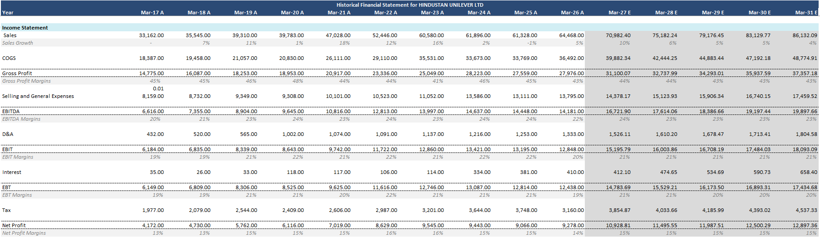
- Revenue for HUL has grown from Rs. 33,162 Cr in 2017 to Rs. 64,468 Cr in 2026.
- The current year's revenue growth reflects an improvement from the growth recorded in the previous two years.
- This shows a CAGR 7.67%. This indicates a consistent top-line growth.
- Estimated sales (2027-2031) show a stable growth indicating towards a mature company.
- The profit margins indicate a strong operational efficiency.
- Estimated Gross Profit Margins (2027-2031) are also stable indicating sustainable pricing power.
- The projected EBITDA margin of approximately 23% suggests the company is expected to maintain operational efficiency while supporting revenue growth.
- The current year's revenue growth reflects an improvement from the growth recorded in the previous two years.

Hindustan Unilever Ltd Balance Sheet Analysis :
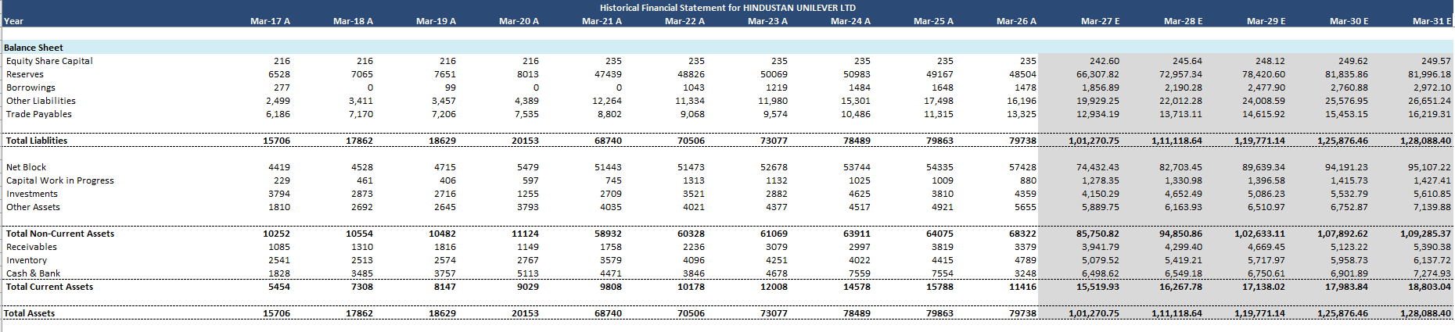
- For the equity share capital, a slight change can be seen from the FY 2021, possibly due to corporate actions like a merger.
- A huge jump can be seen in the Reserves in FY2021, the major reason being the GSK Healthcare Merger.
- Major funding comes from Equity, relies very less on Debt.

Hindustan Unilever Ltd. Cash Flow Statement Analysis:

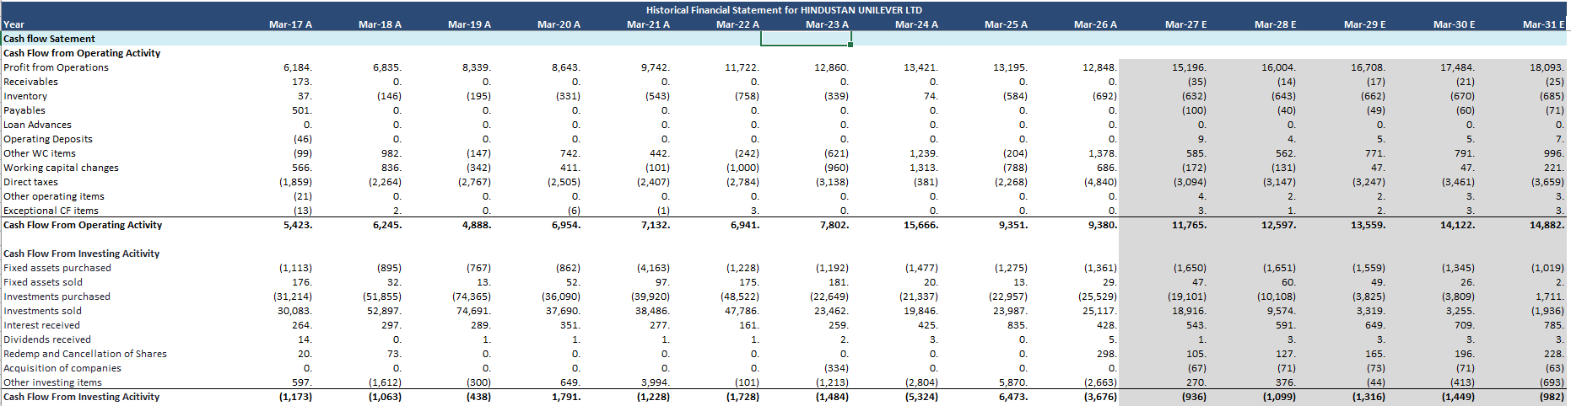
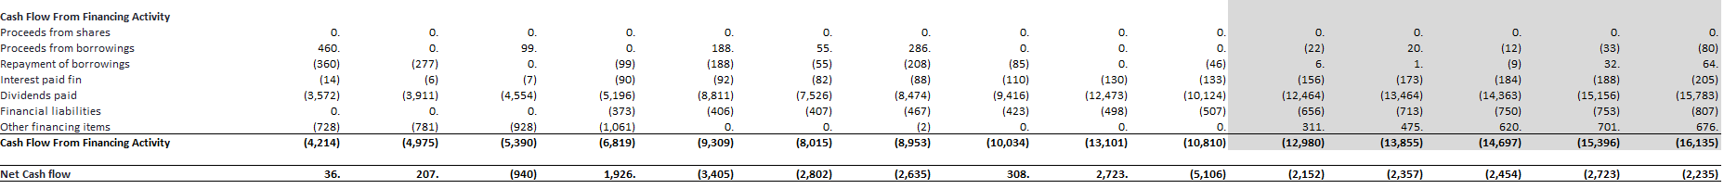

- Steady and consistent growth can be seen in CFO. This reflects a robust business model, working capital efficiency, and brand-led pricing power.
- The sudden increase in the CFO in FY2024 was likely due to one-time working capital inflows or tax benefits.
- The CFI show mostly capex outflows expect for FY2020 and FY2025, which suggests non-core asset monetisation in these years.
- For the CFF, outflow of Rs. 13,101 Cr. Suggests either a larger dividend or settlement of lease/other liabilities.
- Despite fluctuations in net cash flow, the company maintains healthy operating cash flows, enabling it to comfortably fund capital expenditure and dividend distributions without significant reliance on debt.

Valuation of Hindustan Unilever Ltd.

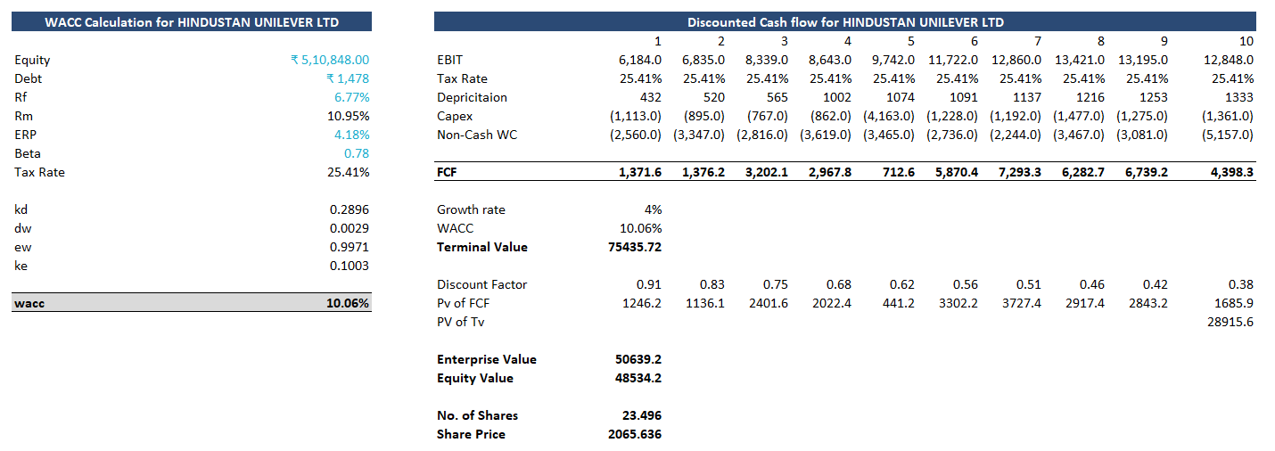
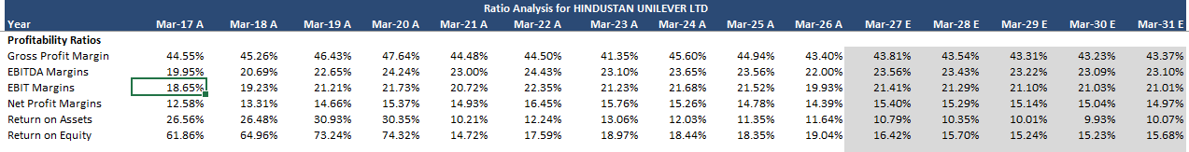
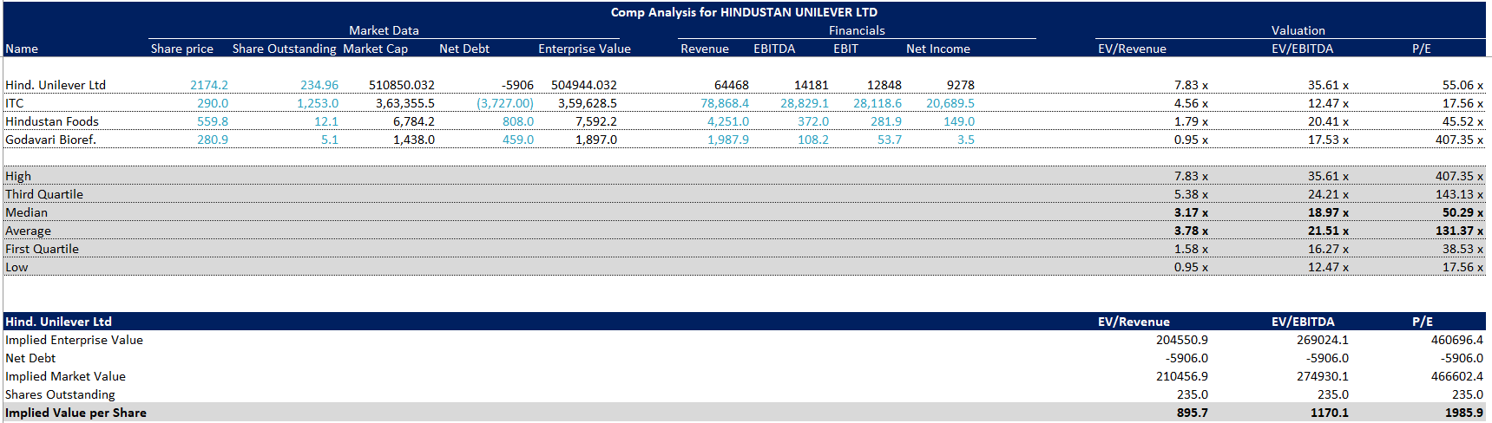

- Current valuation is premium but defendable due to high return ratios (ROE ~19%), exceptional cash flows, predictability in earnings.
- However, future returns may be capped unless:
Rural demand sees a sharp rebound.
New growth categories like premium skincare and beverages scale materially.
Margin expansion or new product penetration surprises on the upside.
- P/E ratio of 52.05 in the FY 2026 indicates a premium valuation, which is in line with the historical averages (typically 45-70x).
- EV/EBITDA multiple is almost 35x, which is generally considered high. This suggests high market expectations for HUL’S profitability and growth.
- The share price is slightly overvalued, ranging from Rs. 2200 – Rs. 3200.
- Dividend yield is modest, but payout ratios are high.

Ratio Analysis for HUL Unilever LTD.

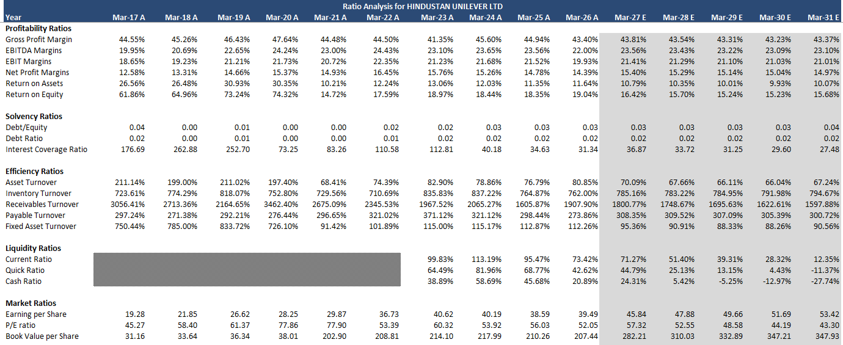
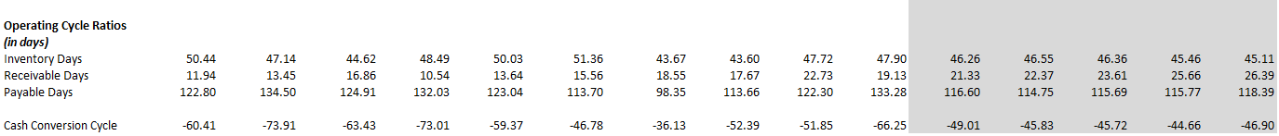

- Gross Profit Margin remained stable between 43% and 46%, indicating strong pricing power and effective cost management despite, fluctuations in raw material costs.
(GPM ranges from 41.35% to 47.64% and stays around 43–45% in the forecast)
• EBITDA and Net Profit Margins remained consistently strong at around 22–24% and 14–15%,
reflecting stable operating profitability.
(EBITDA Margin of 22–24% and Net Margin of 14–15%.)

• ROE declined after FY2021 and stabilized around 18–19%, mainly due to the increase in
shareholders' equity following the GSK Consumer Healthcare merger.

- The company maintains a very low Debt-to-Equity ratio (around 0.02–0.04) and a high Interest Coverage Ratio (above 25x), indicating low financial risk and a strong ability to service debt.

- Inventory and Receivables Turnover remained strong, while the negative Cash Conversion Cycle indicates efficient working capital management, allowing the company to collect cash before paying suppliers.
(CCC remains negative throughout the period.)

Conclusion:
Hindustan Unilever Ltd. is a financially strong and well-established FMCG company with stable revenue growth, consistent profitability, and robust cash generation. The company maintains a conservative capital structure by relying primarily on equity while keeping debt at a minimal level. Strong operating cash flows, efficient working capital management, and healthy profitability ratios reflect its sound financial position. Although the stock currently trades at a premium valuation, its strong brand portfolio, resilient business model, and consistent financial performance support its long-term growth potential. Overall, Hindustan Unilever remains a fundamentally strong company and a suitable long-term investment for investors seeking stable and sustainable returns.

